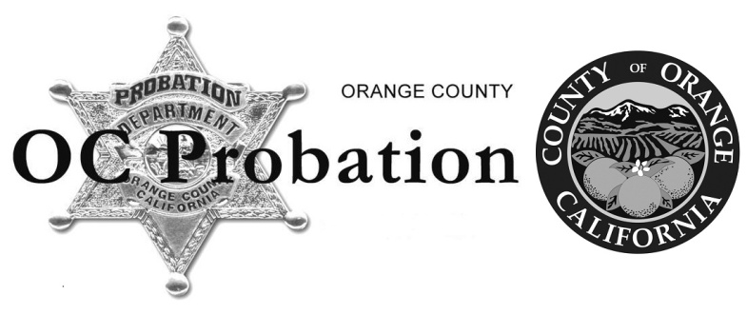 | STEVEn J. SENTMAN  CHIEF PROBATION OFFICER  TELEPHONE: (714) 645-7000  1055 N. Main Street, 5th floor  Santa Ana, CA 92701  MAILING ADDRESS:  P.O. BOX 10260  SANTA ANA, CA 92711-0260

AUTHORIZATION FOR RELEASE OF INFORMATION
Government Code Section 1031, Subdivision (d) provides that each class of Public Officer or Employees declared by law be Peace Officers shall "Be of good moral character, as determined by a thorough background investigation."

Government Code Section 1031.1, (a) For purposes of performing a thorough background investigation for applicants not currently employed as a peace officer, as required by subdivision (d) of Section 1031, an employer shall disclose employment information relating to a current or former employee, upon request of a law enforcement agency, if all of the following conditions are met:
(1) The request is made in writing.
(2) The request is accompanied by a notarized authorization by the applicant releasing the employer of liability.
(3) The request and the authorization are presented to the employer by a sworn officer or other authorized representative of the employing law enforcement agency.
Responses to inquiries are protected, even if unsolicited, by the absolute privilege of California Civil Code §47, Subdivision (2) and Government Code §1031.1(b).
As an applicant with the Orange County Probation Department for a Peace Officer position pursuant to §830.5 of the California Penal Code, I am required to furnish information for use in determining my qualifications, suitability and character.
In this connection, I hereby authorize the Chief Probation Officer or other authorized representative of the Orange County Probation Department, bearing this release, or a copy of it, within one year of this date, to obtain any information in your files pertaining to my local criminal history information (Penal Code Section 13300(b)(10), employment or educational reports (20 U.S.C. Section 1232g (a)(2)(A) and California Education Code Section 76242), credit and financial information, including but not limited to, academic, achievement, attendance, athletic, personal history, performance reports, background investigations, polygraph examination reports, any required DOT drug/alcohol testing results, complaints or grievances, any and all disciplinary records and internal affairs investigations completed or in progress, currently or at the time of separation, including those deemed to be confidential and/or sealed and/or deemed withheld pursuant to any prior agreement or court proceeding involving disciplinary matters. I further authorize you to release any photocopies requested by the Orange County Probation Department.
I hereby authorize the Orange County Probation Department to furnish the above information to third parties for official purposes as authorized by law. I further understand that I have waived any right or opportunity to read or review any background investigation report prepared by the Orange County Probation Department.
I hereby release you, as the custodian of such records, and any school, college, university or other educational institution, hospital or other repository of medical records, credit bureau, lending institution, consumer reporting agency, public agency, private or retail business establishment including its officers, employees or related personnel both individually and collectively, from any and all liability for damage or whatever kind, which may at any time result to me, my heirs, family and associates because of compliance with this authorization and request to release information, or any attempt to comply with it.
Further, your responses to this inquiry are shielded from liability by California Civil Code § 47(c).
A photocopy of this release form will be valid as an original thereof, even though said photocopy does not contain an original writing of my signature.
THIS RELEASE WILL EXPIRE ONE YEAR AFTER THE DATE OF SIGNATURE.
Signature: |  |  |  |  |  |  |  |  |  | Date:
 |  |  |  |  | (Signature to be witnessed)
pRINT Name: |  |  |  |  | _________________________________________________________________
A Notary Public or other officer completing this certificate verifies only the identity of the individual who signed the document to which this certificate is attached, and not the truthfulness, accuracy or validity of that document. Civil Code §1189

 | State of |  |  |  |  |  |  |  | On ________________________ before me, |  |  | ,
 |  |  |  |  |  |  | (Name and title of the officer)
 | County of |  |  |  |  |  |  |  | Personally appeared _________________________________________, who proved to me on the basis of satisfactory evidence to be the person(s) whose name(s) is/are subscribed to the within instrument and acknowledged to me that he/she/they executed the same in his/her/their authorized capacity(ies), and that by his/her/their signature(s) on the instrument the person(s), or the entity upon behalf of which the person(s) acted, executed the instrument.
 | OFFICIAL SEAL
 |  |  |  |  |  |  |  |  | I certify under PENALTY OF PERJURY under the laws of the State of California that the foregoing paragraph is true and correct.
 |  |  |  |  |  |  |  |  | WITNESS MY HAND AND OFFICIAL SEAL
 |  |  |  |  |  |  |  |  | Notary's Signature

